What’s New . . .
June 2020

Future Business Managers’ Meetings

Our next meeting is scheduled for:

- September 10th, 2020 TBA

Financial Planning & Budget Update

If you would like to present at a future Business Manager Meeting or have suggestions for helpful content, contact Jessica Winet-Fleer at jessica.winetfleer@slu.edu. We would love to hear about best practices in your area as others could benefit as well.

Employment Requisitions
With the employment requisition process transitioning from Banner to Workday, the office of Financial Planning & Budget maintains its responsibility to review the replacement of existing requisitions against budgeted data in Banner until June 30th. For timely approval, notate that the existing position has Cabinet approval for replacement, the related Banner position number, and current budget.
Human Resources
We are asking for your help to thank our frontline workers who have been supporting the SLU community throughout the pandemic. By June 30th, if you can, we ask that you submit a 10-15-second video of you thanking and recognizing our frontline workers. For example, you may want to gather your household members together and say “thank you” as a group, or hold up thank you signs and drawings. Our frontline workers include the custodial staff, public safety officers, and medical staff who have been working hard to keep us safe.
If you choose to participate, please do the following:
- Record your video horizontally.
- Position yourself facing a window or outside. If there are bright lights on behind you, please turn them off.
- Look into the lens.
- Aim to include at least your head and shoulders in the frame.
- Record somewhere with limited background noise.
- Consider wearing Billiken gear to show your SLU pride!
To submit your video, you can upload it to this Google Drive Folder.

Google Drive instructions:
1. Click the link to access the folder.
2. After you open the folder, click “New” in the top left corner.
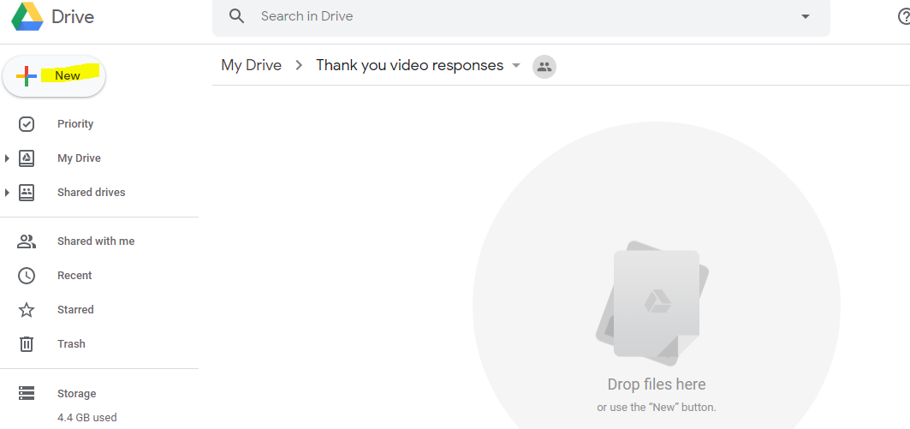
3. Click “File Upload” from the drop down menu.
4. Navigate to the file on your computer and then click “Open.”
5. You’ll see the file uploading in the bottom right corner. Do not exit out of the Drive until that process is complete.)
Thank you for supporting our community, we are OneSLU.
Risk Management

As we approach the new fiscal year, Risk Management would like to remind all employees that drive on behalf of the University that they must renew their Motor Vehicle License Register Check (MVLRC) every fiscal year.

For those with a Missouri license you can go to the Risk Management website - Automobile Insurance section and click on MVLRC.

For out-of-state licenses, please go to the Office of Clinical Education Compliance in DuBourg Hall, Room 20 and ask for an out-of-state license. Bring a valid driver’s license. No appointment is necessary.

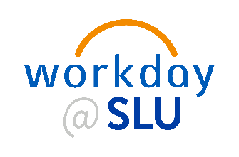
Workday Update
The last set of open forums have been scheduled this week leading up to the launch of Workday Phase 2 on July. 1. Be sure to join to learn more details about changes to procurement and pre go-live training opportunities.
Members of the project team, as well as representatives from Finance and Information Technology Services (ITS) will be on hand to provide information and to answer your questions.
The forums will be held via zoom:
- Wednesday June 10th @ 8am
- Thursday June 11th @ 2pm
To learn more about SLU’s journey to Workday and read the FAQs, visit Workday@SLU.

Workday Financials Cutover Period Coming
As Saint Louis University moves closer to launching Workday Financials on July 1, there will be a cutover period between the time when SLU shuts down existing systems and begins to process work in Workday.
Below is an overview of the timeline for this transition, including key blackout dates for certain systems and deadlines for certain transactions.

Billiken Buy
June 12
This will be the last day in FY20 that orders can be placed in Billiken Buy. Billiken Buy access will be shut off at the end of the business day.
June 26
You will still be able to receive Billiken Buy orders and accept invoices against blanket orders until June 26.
July 6
Purchase orders will not be converted to Workday. All purchase orders in Banner will need to be recreated in Workday by the departments, beginning on July 6. This includes W orders (construction purchase orders) and grant blankets.
July 6
While Workday Financials officially launches July 1, general users will not be able to access Billiken Buy until July 6 so that the project team can perform live testing with suppliers on July 1 and 2.

PCard
June 30
By the close of business, all remaining P Card transactions to be reviewed/approved in the AMEX reconciliation tool.

Concur
June 15
This is the final day for departments to submit expense reports to the Commitment Offices for approval or to create travel bookings in Concur.
June 16 – 30
If you must book travel between June 16-30, call TravelPlex directly at 314-569-1900.
July 1
Travel booking and expense report submissions in Concur resume on July 1.

Vendor Setup Requests
June 24
This is the final day for departments to submit vendor set-up creation requests to Accounts Payable to process a direct payment voucher (DPV) for the June 30 check run.
June 12 –26
We will allow departments to submit supplier requests in Billiken Buy during this period. Vendors that register during this timeframe will be connected and available to order from after Workday is live on July 6.

Vendor Payment
June 26
Final day for departments to submit DPV's for payment for the June 30 check run.
June 29
Final day for the Commitment Offices to approve for the June 30 check run.

Human Capital Management (HCM) Transactions
Early June
HCM transactions will be cut off towards the beginning of June to reduce issues as we begin moving the new Workday configuration into production. Business Managers should not future date costing allocations to prepare for FY21. These will be loaded by the project team.
After July 1
Business managers need to verify all of their department’s employee information has properly transitioned into the new production tenant of Workday. This includes checking all faculty and staff promotions, costing allocations, salaries, etc. If the information is not correct, the business manager will need to update it in Workday.

Financial Planning and Budget
May 22
As in the past, Financial Planning and Budget will not be able to process budget revisions during the budget roll process. Please submit the remainder of your critical FY20 budget revisions no later than the close of business.
June 1
The budget roll process is slated to begin on or about June 1 for financial budgets. The budgets will then be exported from Banner, converted to Workday financial elements, loaded into Workday and validated.

Wait for Notification for FY21 Budget Availability
Due to the Workday Finance implementation July 1 go-live date, Financial Planning and Budget will notify business managers when the FY21 budgets are available to view in Workday.

Workday Financials (Phase 2) Training Opportunities Available
As we near the launch for Workday Financials on July 1, several opportunities will be offered for training. Training will be offered as webinars, training videos, and job aids.

Training videos and job aids will be available within Workday through the Job Aids and Video Library worklet at go-live.

In addition to the videos and job aids, live webinars will be offered the weeks of June 15 and June 22. Please review the schedule, and sign up in skill soft using the links provided below (Zoom link will be sent closer to training date for those who register):

Foundation Data Model (FDM)
- This training will provide an overview of the core structure of Workday Financials. This includes the key Workday terms and concepts including worktags, cost centers, revenue and spend categories, among others. In addition, we will discuss the mapping between Banner and Workday terminology.
  - Tuesday, June 16, 1-2 p.m.
  - Wednesday, June 17, 8-9 a.m.

Banking & Settlement
- This webinar will provide you with a better understanding of Departmental Deposits in Workday. In this session, you will learn how to create an ad hoc bank transaction for the deposit of cash/checks and credit cards within Workday.
  - Thursday, June 18, 1-2 p.m.
  - Monday, June 22, 1-2 p.m.

Customer Accounts
- Customer Accounts in Workday provides the University with a centralized billing and receiving system to enable timely revenue recognition of non-patient and non-student billings. This webinar will focus on creating customers, invoices, contracts, billing schedules and how to record and apply customer payments.
  - Monday, June 22 9-11 a.m.
  - Friday, June 26, 9-11 a.m.

Procurement
- This webinar will focus on common tasks, including how to create purchase requisitions and blanket orders. We will also show users how they can continue to use Billiken Buy within Workday.
  - Thursday, June 18, 9-10:30 a.m.
  - Tuesday, June 23, 9-10:30 a.m.

Projects
- The training will focus on the types of projects and the process for creating and editing projects and project hierarchies.
  - Tuesday, June 23, 1-2 p.m.

Suppliers
- These sessions will cover supplier requests, Supplier invoice request (DPV replacement), Trip ID, and P Card Verification for cardholders.
  - Friday, June 19, 9-10 a.m.
  - Thursday, June 25, 1-2 p.m.

Talent & Learning
- This webinar will give a better understanding of how the Talent and Learning modules can be used at different stages of your SLU career. Some of these include a professional profile, Talent Attributes, mentorships and succession planning.
  - Wednesday, June 14th 2pm – 3pm
*OVPR is holding daily training sessions on the grants management module starting June 8th. If you need to be a part of these training sessions, please contact Matt Renaud (matt.renaud@slu.edu)

Please check our website for updates. https://www.slu.edu/news/announcements/2020/june/workday-phase-2-training.php

Office of Compliance & Ethics Update
The Saint Louis University Integrity Hotline is available as a confidential, toll-free resource for anyone with a concern regarding, business, billing, and/or ethical practices in his or her department. Anonymous or self-identified reports of any nature can be made to the Integrity Hotline at 1-877-525-5669. Additional information and FAQs regarding the Integrity Hotline can be found at the Office of University Compliance and Ethics homepage. See attached link: https://www.slu.edu/compliance-ethics/hotline.php

