**SUMMER & FALL 2020**

**Course Descriptions**

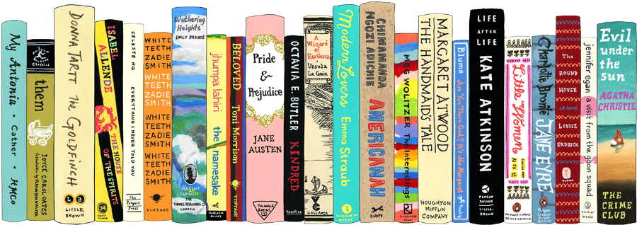

**Department of English**

**Saint Louis University**

**Summer & Fall 2020**

**Course Descriptions**

**Department of English**

**TABLE OF CONTENTS**

**COURSE DESCRIPTIONS:**

SUMMER COURSES………………………………………………………………………………………………………….. 4

COURSES THAT FULFILL ENGLISH MAJOR AND MINOR REQUIREMENTS…………………………… 5-7

ONE-THOUSAND LEVEL COURSES…………………………………………………………………………………..… 8-9

TWO-THOUSAND LEVEL COURSES……………………………………………………………………………….…… 10-11

THREE-THOUSAND LEVEL COURSES…………………………………………………………………………………. 12-16

FOUR-THOUSAND LEVEL COURSES…………………………………………………………………………………… 17-21

FIVE-THOUSAND LEVEL COURSES………………………………………………………………........................ 22-23

SIX-THOUSAND LEVEL COURSES……………………………………………………………………………………….. 24-25

**DEGREE REQUIREMENTS:**

MAJOR IN ENGLISH…………………………………………………………………………………………………………… 26

CONCENTRATIONS………………………………………………………………………………………………… 27

MINOR IN ENGLISH…………………………………………………………………………………………………………… 28

MINOR IN CREATIVE WRITING………………………………………………………………………………. 29

INTERNSHIPS FOR ENGLISH MAJORS…………………………………………………………………………………. 30

3+3 ACCELERATED BA/JD PROGRAM…………………………………………………………………………………. 31

RESEARCH INTENSIVE ENGLISH………………………………………………………………………………………….. 32

SIGMA TAU DELTA ENGLISH HONOR SOCIETY……………………………………………………………………. 33

Cover Image Source: Illustration by artist Jane Mount

**SUMMER 2020 COURSES**

**Summer Session One: May 18th – June 7th**

ENGL 2650-15 Technology, Media, and Literature | ONLINE | Casmier

ENGL 3180-01 Film Narratives: Representations of Business | ONLINE | Casaregola

**Summer Session Two: June 29th – August 9th**

ENGL 1900-02 Advanced Strategies of Rhetoric and Research | ONLINE | McIntire-Strasburg

**SUMMER COURSE DESCRIPTIONS**

**ENGL 1900-02 Advanced Strategies of Rhetoric and Research**

*Janice McIntire-Strasburg*

This completely online course satisfies the requirement for composition.  Students will be reading, writing and researching on topics of their choice.  The course will require logging in to the Blackboard course several times per week, and turning in the writing assignments, which will include summaries of reading material, exploratory essays, abstracts, annotated bibliographies, and a final essay.  Students need to turn in all assignments (on time) in order to pass this course.

**ENGL 2650-15 Technology, Media, and Literature**

*Stephen Casmier*

Through theoretical texts, documentaries, film, stories and novels, this course will explore the ways that technology and the media affect and control our understanding of ourselves and the world.  It will use the ideas of thinkers such as Michel Foucault, Jacques Lacan, Walter Benjamin, Slavoj Žižek, Jean Baudrillard, Naomi Klein, and Walter Ong among others to read *The Hunger Games*, by Suzanne Collins, *A Clockwork Orange*, by Anthony Burgess and *White Noise*, by Don Delillo.  It will also explore the relationship of text to film, and screen documentaries such as Leni Riefenstahl’s *Triumph of the Will* and Stanley Kubrick’s *A Clockwork Orange* (please be forewarned that this film contains potential triggers through its representation of physical and sexual violence). Through this class, students will become acquainted with aspects of cultural studies, various critical perspectives and several approaches to reading literature. The grade in this course will be based on the student's performance on 2 exams (including a take-home midterm in essay format), 2 major papers, several minor writing assignments, journal entries, formal in-class presentations and several short quizzes.

**ENGL 3180-01 Film Narratives: Representations of Business**

*Vincent Casaregola*

**This course fulfills a requirement for the Film Studies Minor.**

This course will introduce students to American film by focusing on films that deal with the business world. Hollywood and American film audiences have always been interested in films that show both the drama and the comedy of life in business, from the lowest entry-level jobs to the fights in the corporate boardrooms. We will look at a diverse range of films from Charlie Chaplin’s Modern Times to Oliver Stone’s Wall Street films (along with others), at the same time looking at different film directors and their distinctive styles. Films will be viewed on the students’ own time. Some can be watched through the SLU Library streaming service; some can be streamed for free online; some will require student rental or purchase (online rentals usually run from 3-5 dollars). Total costs for students should be far less than the cost of many textbooks, and there is no textbook for the course. Total student costs should be under $30.00. Required Texts: Materials will be distributed to the class through the online course system.

**FALL 2020**

**COURSES THAT FULFILL MAJOR AREA REQUIREMENTS**

***ANNOUNCEMENT TO ALL STUDENTS: All English courses now have waitlists. If you wish to enroll in an English course that is either full or has a temporary restriction in place, you should put your name on the waitlist for that course. DO NOT contact the course instructor until you have put your name on the waitlist. Waitlists will be monitored and announcements will be made when either seats become available or when restrictions are lifted. Thank you for your cooperation in this matter!***

ENGL 1900 Adv. Strategies of Rhetoric and Research: Multiple Sections - Consult Banner for Details.

**Introductory Courses**

ENGL 2250-01 Conflict, Social Justice and Literature | TR 11:00-12:15 p.m. | McIntire-Strasburg

ENGL 2250-02 Conflict, Social Justice and Literature | TR 12:45-2:00 p.m. | McIntire-Strasburg

ENGL 2350-01 Faith, Doubt and Literature | TR 3:45-5:00 p.m. | TBD

ENGL 2450-02 Nature, Ecology and Literature | TR 12:45-2:00 p.m. | Chow

ENGL 2550-01 Gender, Identity and Literature | MWF 11:00-11:50 a.m. | TBD

ENGL 2550-02 Gender, Identity and Literature | MWF 12-12:50 p.m. | TBD

ENGL 2650-01 Technology, Media and Literature |MWF 11:00-11:50 a.m. | TBD

ENGL 2650-02 Technology, Media and Literature |TR 2:15-3:30 p.m. | TBD

ENGL 2750-01 & 01H Film, Culture and Literature |MWF 10:00-10:50 a.m. | Casaregola

ENGL 2750-02 Film, Culture and Literature |TR 9:30-10:45 a.m. | Uraizee

**Distribution Requirements**

Area One: Form and Genre

ENGL 3050-01 Creative Writing: Poetry | TR 11:00-12:15 p.m. | Johnston

ENGL 3070-01 Creative Writing: Drama | MW 11:00-12:15 p.m. | Adams

ENGL 3140-01 & 01H Poetry: The Sonnet | R 2:10-4:55 p.m. | Mathys

ENGL 3241-01 Young Adult Literature | T 2:10-4:55 p.m. | Buehler

Area Two: History and Context

ENGL 3280-01 American Literary Traditions after 1865 | TR 9:30-10:45 a.m.| Chow

ENGL 3490-01 19th Century British Literature | TR 12:45-2:00 p.m. | Stiles

Area Three: Culture and Critique

ENGL 3620-01 Topics in Spirituality and Literature | MWF 12:00-12:50 p.m. | Pettit

ENGL 3730-01 Introduction to Medical Humanities | TR 2:15-3:30 p.m. | Stiles

ENGL 3930-01 Politics and Contemporary U.S. Literature | TR 11:00-12:15 p.m. | Greenwald Smith

Area Four: Rhetoric and Argument

ENGL 3850-01 Foundations of Rhetoric Writing | TR 12:45-2:00 p.m. | Lynch

ENGL 3885-01 Writing Personal Narratives | MWF 1:10-2:00 p.m. | Bush

**4000-Level Advanced Writing / Seminars**

ENGL 4000 Business and Professional Writing | Multiple sections and instructors, consult Banner for details.

ENGL 4100-01 History of the English Language | MWF 12:00-12:50 p.m. | Evans

ENGL 4240-01 Chaucer: *The Canterbury Tales* | MWF 1:10-2:00 p.m. | Hasler

ENGL 4500-01 & 01H The Age of Romanticism | TR 11:00-12:15 p.m. | Benis

ENGL 4830-01 Post 1900 African Literature | MWF 10:00-10:50 a.m. | Grant

RIE / English Honors Seminars

ENGL 4020-01 History of Rhetoric I | M 2:10-4:55 p.m. | Casaregola

ENGL 4930-01 The Space of the Page: Texts and Surfaces | TR 12:45-2:00 p.m. | Sawday

Senior Seminar

ENGL 4960-01 Senior Seminar | MWF 11:00-11:50 a.m. | Stump

**GRADUATE COURSES**

ENGL 5000-01 Methods of Literary Research | T 5:00-7:45 p.m. | Greenwald Smith

ENGL 5010-01 Teaching Writing | R 6:00-8:45 p.m. | Rivers

ENGL 5020-01 History of Rhetoric I | M 2:10-4:55 p.m. | Casaregola

ENGL 5170-01 Perspectives in American Literature | M 6:00-8:45 p.m. | Bush

ENGL 6590-01 Liberalisms and 19th Century Literature | MWF 12:45-2:00 p.m. | Weliver

ENGL 6930-01 The Space of the Page: Texts and Surfaces | TR 12:45-2:00 p.m. | Sawday

**COURSES THAT FULFILL MAJOR CONCENTRATION REQUIREMENTS**

Creative Writing

ENGL 3050-01 Creative Writing: Poetry | TR 11:00-12:15 p.m. | Johnston

ENGL 3070-01 Creative Writing: Drama | MW 11:00-12:15 p.m. | Adams

ENGL 3140-01 & 01H Poetry: The Sonnet | R 2:10-4:55 p.m. | Mathys

ENGL 3280-01 American Literary Traditions after 1865 | TR 9:30-10:45 a.m. | Chow

Rhetoric, Writing, and Technology

ENGL 3850-01 Foundations of Rhetoric Writing | TR 12:45-2:00 p.m. | Lynch

ENGL 3885-01 Writing Personal Narratives | MWF 1:10-2:00 p.m. | Bush

ENGL 4000 Business and Professional Writing | Multiple Sections and Instructors: Consult Banner for Details

English Honors Program (RIE English)

ENGL 4020-01 History of Rhetoric I | M 2:10-4:55 p.m. | Casaregola

ENGL 4930-01 The Space of the Page: Texts and Surfaces | TR 12:45-2:00 p.m. | Sawday

**INTERDISCIPLINARY MINOR OFFERINGS**

Creative and Professional Writing Interdisciplinary Minor

*Contact Dr. Devin Johnston with program questions at devin.johnston@slu.edu.*

ENGL 3050-01 Creative Writing: Poetry | TR 11:00-12:15 p.m. | Johnston

ENGL 3070-01 Creative Writing: Drama | MW 11:00-12:15 p.m. | Adams

ENGL 3140-01 & 01H Poetry: The Sonnet | R 2:10-4:55 p.m. | Mathys

ENGL 3280-01 American Literary Traditions after 1865 | TR 9:30-10:45 a.m. | Chow

ENGL 4000 Business and Professional Writing | Multiple Sections and Instructors: Consult Banner for Details

Film Studies Interdisciplinary Minor

*Contact Mr. Ringo Jones with program questions at ringo.jones@slu.edu*

ENGL 2750-01 & 01H Film, Culture and Literature |MWF 10:00-10:50 a.m. | Casaregola

ENGL 2750-02 Film, Culture and Literature |TR 9:30-10:45 a.m. | Uraizee

Medical Humanities Interdisciplinary Minor

*Contact Dr. Anne Stiles with program questions at anne.stiles@slu.edu*

ENGL 3730-01 Introduction to Medical Humanities | TR 2:15-3:30 p.m. | Stiles

**ONE-THOUSAND LEVEL COURSES**

**ENGL 1900 Strategies of Rhetoric and Research**

Multiple sections will be offered. Please consult Banner for sections and times.

Studies complex structures of language including its logical and persuasive possibilities. Emphasizes analytical reading, critical thinking, and research methodology skills. Prerequisite: ENGL-1500, or equivalent. The writing program offers multiple sections of ENGL 1900 that focus on particular lines of inquiry. These sections are described below. Interested students should contact the writing program by email (writingprogram@slu.edu) to find out specific sections and times.

**Gender, Identity, and Rhetoric:** This 1900 offering will examine the ways in which rhetoric illuminates and challenge cultural assumptions and practices related to gender and identity. Learning objectives include the development of rhetorically persuasive messages regarding those cultural assumptions; the composition of a project that stems from meeting audience expectations and that applies gender/identity rhetorics on a practical level; research methods to develop and shape the project; and analysis and synthesis of research into a persuasive message toward a target audience.

**Conflict, Social Justice, and Rhetoric**: This 1900 offering will focus on conflict and social justice issues related to a range of issues, which may include poverty, policing, incarceration, and historical memory, among others. Conflicts around these and other issues have become acute in the last few years, across the nation and right here in St. Louis. By researching these issues and their impact on our society, students will prepare themselves to intervene rhetorically into these and related situations.

**Nature, Ecology, and Rhetoric**: This 1900 offering focuses on humanity’s relationship to the natural world. Human beings are both part of nature but have also often believed that they stand apart from nature. The conflicts between these attitudes have become especially acute in our present moment as humans become aware of the damage they have done to the ecologies that sustain them. Students will study these issues, write about them, and create rhetorically effective responses.

**Medical Humanities and Rhetoric**: This 1900 offering explores the connection between medicine and the humanities as an avenue of inquiry into the complex structures of language, especially its rhetorical and persuasive possibilities. As in other 1900 sections, analytical reading, critical analysis, and research methodology skills will be emphasized; however, they will be particularly honed through the exploration of issues like medical ethics, death and disease, disability, and patient rights.

**Faith, Doubt, and Rhetoric**: This 1900 offering will analyze and research the role of religious discourse in public life in the United States. Students will read and write about a wide variety of rhetorical discourses, religious, anti- religious, and non-religious. Some course sections will focus on the history of these arguments in the U.S., while others may focus on the contemporary emergence of “seekers” (those who are exploring religious affiliations) and “nones” (those who claim no such affiliation). As in other 1900 sections, students will conduct library research in order to develop their own critical inventions in this discourse. They will produce not only traditional written arguments, but also multimodal persuasive texts.

**Technology, Media, and Rhetoric**: This 1900 offering will focus on new and emerging technologies that are reshaping human relations: from the now ubiquitous smartphone and increasingly popular wearables like the Fitbit to the potentially all-encompassing Internet of Things. New modes of communication provide new ways of mediating the human experience, though they also present new challenges for connecting with and moving others, a chiefly rhetorical task. Through sustained writing and rewriting, students will think and argue their way through these challenges by utilizing the very communication technologies the course is critically engaging.

**TWO-THOUSAND LEVEL COURSES**

**Introductory Coursework for the English Major**

**\*\*All 2000-level courses also fulfill a College of Arts and Sciences core literature requirement\*\***

**ENGL 2250-01 & 02 Conflict, Social Justice, and Literature**

*Janice McIntire-Strasburg*

Native American Cross-Cultural Confrontations at First Contact and Beyond: This course will provide readings from indigenous and western authors that depict the cultural struggle for Native Americans as they attempt to keep alive their tribal cultures and religions in the face of American Removal, assimilation, and/or eradication.

**One section of ENGL 2350, Faith, Doubt, and Literature, will be offered**

**ENGL 2450-02 Nature, Ecology, and Literature**

*Juliana Chow*

This course introduces students to the study of literature through writings about the environment.  Through the lens of literature, we will scrutinize the concepts that inform our understanding of “nature” and how these concepts, in turn, play out in literary forms.  We might think of “environmental literature” as directly engaging with issues that are at the forefront of our consciousness such as anthropogenic (human-caused) environmental change, from pollution to global warming.  It is true that texts have been pivotal in galvanizing environmental activism around a specific problem such as Upton Sinclair’s *The Jungle*concerning meat production and Rachel Carson’s *Silent Spring*concerning DDT.  However, literature’s relationship to the environment, just like our own senses of the environment, is also often indirect and more multivalent than a single issue-oriented message; and we will explore how aesthetics, tropes, narratives, and complex cultural and historical contexts in literature contribute to our senses of the environment and how it comes to be meaningful to us.  Assignments will include weekly close-reading papers, essays, presentations, and discussion participation.

**Two sections of ENGL 2550, Gender, Identity, and Literature, will be offered**

**Two sections of ENGL 2650, Technology, Media, and Literature will be offered**

**ENGL 2750-01 & 01H Film, Culture, and Literature**

*Vincent Casaregola*

This course introduces students to the critical study of film and literature in relationship to one another, focusing on how genre can be used to examine that relationship, as well as how it can be a window on the culture at large. The course will focus on how, especially in the American cultural tradition, genre has often defined the production and reception of both film and literature.

We will study three different genres: Detective/Noir, Science Fiction/Dystopia, and War.  In examining each of these, students will read works of fiction that represent the literary form of the genre, while also viewing and analyzing films from the same area. Sometimes, we may read a work and then view a film based on that work. At other times, we will view films that represent the same genre but are not specifically derived from the novels we read. Films will be viewed on the students’ own time, through streaming services or from works on reserve. As much as possible, I will assign films available for free online. Otherwise, students may rent the films for viewing (most such rentals cost between 3-5 dollars).

**ENGL 2750-02 Film, Culture, and Literature: “Love and War”**

*Joya Uraizee*

This course is designed to satisfy the foundation requirement for the Film Studies Certificate as well as the 2000 level literature requirement for the English major and for the Arts and Sciences core. You will closely examine a novel and several films from all over the world. Over the course of the semester you consider the various ways in which these texts reflect and shape wider cultural conditions, and you will construct clear spoken and written arguments about them.   Some of the texts you will view or read include: Michael Chabon’s *The Amazing Adventures of Kavalier and Clay* (2000)*,* Marguerite Abouet & Clement Oubrerie’s *Aya of Yop City* (2013), Ryan Coogler’s *Black Panther* (2018), Wanuri Kahiu’s *Rafiki* (2018), Al-Kateab & Watts’ *For Sama* (2019), Greta Gerwig’s *Little Women* (2019), and Bong Joon-ho’s *Parasite* (2020). The requirements for the course include quizzes, 2 short papers, a midterm exam, and a final written and oral group project.

**THREE-THOUSAND LEVEL COURSES**

**Distribution Requirements for the English Major:**

**Area One: Form and Genre**

**ENGL 3050-01 Creative Writing Special Topics: Poetry**

*Devin Johnston*

**This course fulfills requirements for the English major with Creative Writing concentration, the Creative Writing minor, and the interdisciplinary minor in Creative and Professional Writing. Registration for this course is restricted, for a period of time, to English majors, English minors, and Creative Writing minors. Non-major/minor students should put their names on the waitlist. Announcements will be made when the restriction is lifted.**

This course will introduce students to a range of methods and techniques for writing poetry, making use of a few compelling models on which to base our own writing (both reading and writing will be assigned). In this sense, the course will constitute an apprenticeship to poetry. We will begin as beginners, with experiment and play. No previous experience in the writing of poetry is required, only enthusiasm. Each week students will bring poems for discussion, developing a portfolio of revised work by the semester’s end. Students will also be expected to attend several poetry events.

**ENGL 3070-01 Creative Writing Special Topics: Drama**

*Lindsay Adams*

**This course fulfills requirements for the English major with Creative Writing concentration, the Creative Writing minor, and the interdisciplinary minor in Creative and Professional Writing. Registration for this course is restricted, for a period of time, to English majors, English minors, and Creative Writing minors. Non-major/minor students should put their names on the waitlist. Announcements will be made when the restriction is lifted.**

This course will introduce you to writing for the stage. No prior experience with playwriting and theatre is necessary (although it is welcome!); we’ll work from the ground up. This is a course that not only welcomes but requires experimentation and an engagement with process. The first half of the course will focus on characters, conflict, and dialogue as the basic building blocks of theatrical writing. After learning how to give and respond to constructive feedback, as a class we will workshop the scenes you write. Theatre is meant to be heard and performed, and you will be expected to participate by reading parts in your classmates’ scenes. We will read, watch, and analyze plays throughout this course, mostly contemporary works, but also some older playwrights to give examples of different writing styles. To learn to write for the theatre, you need to build as much experience as you can reading scripts and attending performances. You will be expected to attend theatrical performance in the St. Louis area, on campus and off. In the second half of the course, you will develop a longer script idea. At this point we will layer in and work on incorporating additional elements of storytelling, such as structure, imagery, theme, and pacing. By the end of the semester, each student will produce a final portfolio, including flash dramas, at least two ten-minute plays, and either a one-act or a partial full-length play

**ENGL 3140-01 & 01H Poetry: The Sonnet**

*Ted Mathys*

**This course fulfills requirements for the English major with Creative Writing concentration, the Creative Writing minor, and the interdisciplinary minor in Creative and Professional Writing. Registration for this course is restricted, for a period of time, to English majors, English minors, and Creative Writing minors. Non-major/minor students should put their names on the waitlist. Announcements will be made when the restriction is lifted.**

The sonnet is one of the most popular and enduring poetic forms in the English language. Equally compact and expansive, energetic and adaptive, the sonnet provides a window through which to see many of the major questions of poetry at work. This course will survey the development of the English language sonnet, from the early sixteenth century to the present. The course will begin with the sonnet’s two dominant modes – the Petrarchan and the Shakespearian – and will progress over the semester through a range of sonnet permutations and experiments, such as unrhymed sonnets, double sonnets, broken sonnets, prose sonnets, sonnet erasures, anagram sonnets, and more. By reading, analyzing, and writing about sonnets, students will gain facility with elements of poetic form, such as lineation, stanza structure, rhyme, and meter. Each week we will read a handful of sonnets along with secondary texts that place each poet and their sonnets in context. We will also engage other faculty experts from the English Department to contribute to our discussions of historical contexts. Our archive will include classic sonnets from Wyatt, Sidney, Shakespeare, Donne, Milton, Wordsworth, Shelley, Keats, Elizabeth Barrett Browning, and Gerard Manley Hopkins; as well as a range of more recent sonnets from Edna St. Vincent Millay, Elizabeth Bishop, Ted Berrigan, Terrance Hayes, Jen Bervin, Paul Legault, Mathias Svalina, Kimiko Hahn, Olena Kalytiak Davis, Monica Youn, Ben Lerner, and more. Students will be expected to read closely, write several analytical essays, take a midterm exam, and contribute to lively class discussions.

**ENGL 3241-01 Young Adult Literature**

**This course fulfills requirements for the English major with Creative Writing concentration, the Creative Writing minor, and the interdisciplinary minor in Creative and Professional Writing.**

*Jennifer Buehler*

With more books being published annually for teens than ever before, the field of adolescent literature, or YA lit, is flourishing. YA titles are showing up on bestseller lists, being turned into popular movies, and finding a place in many middle and high school English classrooms. Although the field has seen tremendous growth and innovation in the past decade, many people still associate YA lit solely with the “problem novels” of the 1970s, the series books of the 1980s, or recent blockbuster hits such as *Twilight*. In doing so, they grossly underestimate the richness and complexity of this literature.

In this course, we will immerse ourselves in an exploration of the current state of YA lit, from its modern origins in the 1960s to its most recent thematic and literary innovations. Designed with beginning English teachers in mind but also intended to meet the needs of English majors and others with a general interest in the topic, the course will engage participants in intensive reading of a wide variety of classic and contemporary YA texts. Our reading will be anchored by close analysis of these texts as well as ongoing conversation about the field of YA lit as it is shaped by publishers, book critics, and award committees. We will interact with authors and other experts in the field through telephone conference calls. Our work will be both intellectually rigorous and pragmatically grounded as we link conversations about literature to real-world contexts.

The following questions will guide our work together: What is YA lit, and who decides? How has the field of YA lit grown and changed over the past four decades? What tensions and debates shape the current conversation about YA lit? How can we support teens and adults in meaningful readings of YA lit?

**Area Two: History and Context**

**ENGL 3280-01 American Literary Traditions After 1865**

*Juliana Chow*

**Registration for this course is restricted, for a period of time, to English majors, English minors, and Creative Writing minors. Non-major/minor students should put their names on the waitlist. Announcements will be made when the restriction is lifted.**

How do we approach American literature from 1865 through the turn-of the-century where, as one literature anthology for this period puts it, “these years brought wealth to some and stature to America in the eyes of the world” but also “the undesirable consequences of rapid territorial, population, and industrial expansion were felt most by those with the least resources to resist the greedy, unscrupulous, and powerful”?  Exploring literary realism, naturalism, and regionalism, and their connections to earlier nineteenth-century forms of domestic or sentimental fiction and local color, as well as to later modern, postmodern, and contemporary experiments of the twentieth and twenty-first century, the course will consider how literature relates to its historical and cultural moment through form.  What literary techniques and aesthetics are at play in the representation of the period’s social reforms and individual consciousnesses, racialized and gendered divides, class hierarchies and labor processes, urban industries and technological innovations?  How does the writing of this period work with and transform the capacities of literature to attend to the concomitant work and transformation of life from the everyday scale of the person to the abstract aggregate of populations?  Rather than reading excerpted sections of texts across the breadth of an anthology, we will read a selection of whole works in depth wherever possible.  Assignments will include weekly close-reading papers, essays, presentations, and discussion participation.

**ENGL 3490-01 19th Century British Literature**

*Anne Stiles*

**This course meets a requirement for the Medical Humanities interdisciplinary minor.**

This course examines the literature and history of nineteenth-century Britain with an emphasis on medicine, public health, and the built environment. Readings will include Steven Johnson’s *The Ghost Map,* a history of the 1854 cholera epidemic, alongside poems, short stories, and novels by George Eliot, Charles Dickens, Alfred, Lord Tennyson, and other authors of the period. Students will also visit local Victorian house museums and watch relevant documentaries to learn how people in the nineteenth century really lived and the health threats they faced on a daily basis. Finally, students will learn about pseudoscientific movements such as mesmerism, spiritualism, and other occult trends that coexisted uneasily alongside the mainstream medical knowledge of the period.

**Area Three: Culture and Critique**

**ENGL 3620-01 Topics in Spirituality and Literature**

*Kent Pettit*

English 3620 will examine religious spirituality in the context of cultural identity and/or community. How does personal spirituality relate to belonging to a group? How does religious identity and fellowship with other spiritual people contribute to the health of an individual or society? Who is included and excluded from such a community? Such questions will be taken up as we read Jane Austen’s *Mansfield Park*, Charles Dickens’s *A Christmas Carol*, the poetry of Christina Rossetti, James Baldwin’s *Go Tell It on the Mountain*, Zadie Smith’s *White Teeth*, and Wendell Berry’s *Jayber Crow*. We will also look at excerpts from earlier religious writers such as Bede, Margery Kempe, and Richard Hooker. As with any upper-division English course, students will be required to read closely and intelligently, integrating cultural understanding in the analysis of the texts

**ENGL 3730-01 Introduction to the Medical Humanities**

*Anne Stiles*

**This course meets a requirement for the Medical Humanities Interdisciplinary Minor.**

This course explores humanistic and cultural dimensions of health care as represented in literature, with an emphasis on perspectives. First, students will gain historical perspective by exploring how diagnoses and treatments of given illnesses evolve over time. Second, students will read narratives of illness from physician, patient, and family perspectives. They will use these texts as models as they write two creative essays about an illness of their choice, the first from a patient perspective and the second from the perspective of a friend or family member of that patient. Course assignments also include a twenty-minute presentation on a book related to course themes and regular webposts about course readings. Readings may include Lucy Grealy’s *Autobiography of a Face* (1994), Roxanne Gay’s *Hunger* (2017), Akhil Sharma’s *Family Life* (2014), and Alice Munro’s “The Bear Came Over the Mountain” (1999), among other texts.

**ENGL 3930-01 Politics and Contemporary U.S. Literature**

*Rachel Greenwald Smith*

From novels that grew out of the social upheavals of the 1960s to those that engage with the U.S.-Mexico border crisis today, this class will examine how American literature responds to varied and turbulent political contexts. Beginning with Thomas Pynchon’s *The Crying of Lot 49* (1965), which questions the very possibility of acting politically in a system that seems to overwhelm individual agency, we will look at several examples of political conflict in our recent past and literary works that have responded to them. We will explore Toni Morrison’s examination of black power movements in *Song of Solomon* (1977); Don DeLillo’s interrogation of the culture of late capitalism in *White Noise* (1985); Karen Tei Yamashita’s reflection on the social effects of globalization and free trade in *Tropic of Orange* (1997); Mohsin Hamid’s examination of the post-9/11 moment in *The Reluctant Fundamentalist* (2007); and Valeria Luiselli’s heartbreaking meditation on child migration, detention, and deportation in *The Lost Children Archive* (2019), among others. While most of our focus in this class will be on the novels themselves, we will also dip into historical and theoretical sources to help us understand the political dilemmas with which the literary works grapple. Assignments will include reading quizzes, a midterm, a final exam, and two papers.

**Area Four: Rhetoric and Argument**

**ENGL 3850-01 Foundations in Rhetoric and Writing**

*Paul Lynch*

**This course meets a requirement for the English major with Rhetoric, Writing and Technology concentration.**

Rhetoric, writes George Kennedy, is a kind of energy: “the emotional energy that impels the speaker to speak, the physical energy expanded in the utterance, the energy level coded in the message, and the energy experienced by the recipient in decoding the message.” Our project in this course will be to follow rhetoric’s energy, which is firing long before a speaker’s intention. As Kennedy’s definition also suggests, the range of rhetorical discourse extends far beyond the familiar haunts of the civic. Anytime we speak in order to invite someone to conversation or cooperation, no matter the circumstances, we are engaging in rhetoric. In addition, rhetoric extends far beyond the spoken or written word. Even everyday objects and experiences are rhetorically charged. A speaker’s dress or a room’s decoration—to say nothing of an audience’s mood—are often far more persuasive than words anyone says. Our study in this course will include all these available means. We’ll go far beyond conventional understandings of persuasion (i.e., purpose, audience, context, ethos, pathos, logos—in other words, all the stuff you learned in English 1900). Given that we’ll meet this fall, we’ll pay some attention to political campaigns. But we’ll also pay attention to more everyday experiences of rhetoric. Students can expect a fair bit of reading, along with bi-weekly papers, a midterm and a final.

**ENGL 3885-01 Writing Personal Narratives: American Selves**

*Hal Bush*

**This course meets a requirement for the English major with Rhetoric, Writing and Technology concentration.**

This course is a survey of major American literature of all time periods, centered on personal narrative, memoir, and/or autobiography. We’ll give frequent consideration to the historical and cultural forces that influenced the various writers, and our primary focus will be on a close reading, understanding, and critical analysis of the works themselves. The course’s Socratic method will often include students being called upon by the instructor and being asked to give their responses to the readings for the day. It will also assume frequent in class quizzes, mandatory attendance and reading, and rigorous in-class discussion and debate. These aspects of the course are thrilling for some students but intimidating to others. Thus, if such features of ownership and class participation are not to your liking and/or offensive to your sensibilities, this may not be the class for you.

Particular attention will be reserved for figures generally recognized as America’s major writers: the poets Walt Whitman and Emily Dickinson; and masters of prose fiction and non-fiction, such as Frederick Douglass, James Baldwin, Fanny Fern, Joan Didion, Mark Twain, Anne Lamott, and David Foster Wallace.

**FOUR-THOUSAND LEVEL COURSES**

**ENGL 4000 Business and Professional Writing**

*Janice McIntire-Strasburg*

**This course meets requirements for the English Major with Rhetoric, Writing and Technology Concentration and the Creative and Professional Writing Interdisciplinary Minor. This course is for occupational therapy students only.**

ENGL 4000 provides an interactive learning experience that asks students to communicate clearly and efficiently with business professionals. In this course, students will be asked to create and deliver professionally designed and rhetorically sophisticated projects. In addition to communicating clearly and efficiently—coordinating projects and deadlines, working collaboratively, scheduling meetings, reporting progress—students will learn not only to communicate the values of their employers, but also to articulate the value(s) of their own work. The course asks students to create a range of professional documents that both contribute to collaborative projects and refine individual professional identities.

**ENGL 4020-01 History of the Rhetoric I**

*Vince Casaregola*

**This is a dual-level course with English 5020. This is RIE / English Honors Seminar I: Enrollment is restricted to senior and junior English majors only.**

Rhetoric is almost a dirty word these days, used to disparage and criticize one’s political opponents for spouting nothing but false or empty statements.  Of course this usage is largely inaccurate, and it cuts us off from great intellectual and cultural traditions that provide much of the basis for our educational system and many of our cultural institutions.

Fundamentally, rhetoric is the study of how we use language (and other forms of representation) to communicate effectively with others (individuals, groups, and the culture at large).  Indeed, the study of rhetoric is the study of how we build and maintain successful human relationships—interpersonal relationships, social relationships, and political relationships. It is also the study of how we teach people these skills.

This course will provide a survey of the major writers on the subject of rhetoric from the ancient Greco-Roman world through the Renaissance. It will use an anthology, *The Rhetorical Tradition*, containing significant segments of the major works on the subject. Throughout the course, we will examine how the history of rhetorical studies interacts with broader patterns of cultural history that have shaped educational and cultural traditions for thousands of years. At each stage, we will also explore how traditional modes of rhetorical theory and practice, as we now understand them, may be applicable in the contemporary world.

**ENGL 4100-01 History of the English Language**

*Ruth Evans*

When was “they” first used as a singular pronoun? [[It was 1375](https://public.oed.com/blog/a-brief-history-of-singular-they/).] Is African American Vernacular English (AAVE) a language or a dialect? [What’s the distinction?] Why is the spelling system of English so weird? [Answer: the Great Vowel Shift.] Why does language change? And did you know that we haven’t always had dictionaries? This course surveys the linguistic and cultural development of the English language, from its Indo-European roots to its status as a twenty-first century global language. Drawing on literary examples from the different historical periods, we will study the language and pronunciation of Old English (before 11th century), Middle English (12th-15th centuries), Early Modern English (16th-18th centuries), and contemporary dialects and varieties of English, including British and American English, AAVE, tweets, and emojis, with frequent recourse to the resources of both the Oxford English Dictionary and Urban Dictionary. The course will examine the cultural and historical context for language change, including the influence of invasions and wars, literary and material culture, and social identities such as gender, race and ethnicity, social class, nationality, sexual orientation, religion, and age. We will consider social variation and regional variation, “standard” and “non-standard” English, spelling reform, linguistic “correctness,” attitudes to English, and the important variations of English around the world. The course is for all students who are curious about the English language and all students of English literature. You will be required to use the International Phonetic Alphabet (IPA), but the course does not require any background in language or linguistics; the IPA and the tools for describing and analyzing language (linguistic concepts like phonology, semantics, morphology, and syntax) will be taught in the course. You will need to buy:

Smith, K. Aaron, and Susan M. Kim. *This Language, A River: A History of English*. Broadview, 2017. ISBN 9781554813629 and Crystal, David. *The Stories of English*. Overlook, 2005. ISBN 978-1585677191.

Assignments include: two short papers and one longer research paper. No exams. Regular short exercises to test your knowledge of the material.

**ENGL 4240-01 Chaucer: *The Canterbury Tales***

*Anthony Hasler*

Readers of all periods have found something to enjoy in Chaucer’s Canterbury Tales, probably the best-known single work to survive from medieval England. In introducing students to the range of characters, narratives and genres so vibrantly on display in Chaucer’s great collection of stories, this course will not lose touch with whatever it is that still makes the Tales enjoyable today, more than six hundred years after their author’s death. However, it will also attempt to explore the social and cultural contexts that make the Canterbury Tales a creation of its own time and place, including its beginnings not as a neatly-edited course text with helpful footnotes and glossary, but in a messier (perhaps richer?) world of textual production in which everything was written by hand. We will also, I hope, gain some sense of why the work has proved of interest in a variety of current critical perspectives, and consider what, in general, it means to enjoy the Middle Ages.

The tales will be read in the original Middle English, and some attention will be given to the specifics of Chaucer’s language. Requirements: two papers, a midterm, a final, class participation and some translation and pronunciation exercises.

**ENGL 4500-01 & 01H The Age of Romanticism: The Road to *Frankenstein***

*Toby Benis*

1816 was “the year without a summer” in Great Britain; at the other end of the globe, a volcanic explosion discharged so much dust into the atmosphere that temperatures across the earth were well below historical levels.  This geologic event was accompanied by parallel upheavals among artists and writers. In this year, Lord Byron rented the Villa Diodati, on the shores of Lake Geneva; his presence there attracted Percy and Mary Shelley and Matthew Lewis, along with a parade of other literary celebrities.  This course will explore the literature written during the summer of 1816 by Byron, Percy and Mary Shelley, and John Polidori, Byron’s physician. Most famously, Mary Shelley’s Frankenstein was written during the cold, wet summer of 1816; we will read work that influenced Shelley’s narrative, including texts by Samuel Taylor Coleridge, Humphrey Davies, and John Milton, as well as the responses to Shelley’s novel (including a number of theatrical adaptations).  At the Villa Diodati Byron wrote canto III of *Childe Harold’s Pilgrimage*, “The Prisoner of Chillon,” and his autobiographical drama about brother-sister incest, *Manfred*.  John Polidori’s *The Vampyre* was the product of the same ghost story competition that incited Shelley’s work on her novel.  And Percy Shelley wrote a number of his most famous lyrics, including “Mont Blanc” and “Hymn to Intellectual Beauty,” on Lake Geneva in 1816.  We will supplement these readings with various background materials, such as works that framed perceptions of Geneva for Romantic audiences (e.g. Jean-Jacques Rousseau’s *The Confessions*), and Johann Wolfgang von Goethe’s classic poem of the Romantic over-reacher, *Faust*.  Coursework will include two papers, two exams, and spirited class participation.

**ENGL 4830-01 Post 1900 African Literature: The Harlem Renaissance**

*Nathan Grant*

*When did the Harlem Renaissance begin?*  This is a difficult question.  It’s hard enough to establish the birth date of anything in literature, let alone chart its rebirth.  But the curious thing about the Harlem Renaissance is that it seems to have enjoyed its rebirth (hence the name) without ever having first established *a* birth.  For its literary aspect, which is the focus of this course, some give as an official year 1923, the year of the publication of Jean Toomer’s enigmatic *Cane*, perhaps the most lyrical work to have emerged from the period. Others prefer 1918, the end of World War I, which for African Americans culminated with James Reese Europe’s marching band leading the 369th Regiment up fashionable Fifth Avenue, and into Harlem.  Some like 1925, the year of the first literary prizesgiven by *Opportunity*, the magazine of Charles S. Johnson and the Urban League, and *The Crisis*, the weekly of W. E. B. Du Bois.  This is also the year of the publication of Alain Locke’s anthology of essays, short fiction, art and verse, *The New Negro.*

But there was much activity before 1925, and if *Cane* is “about” migration, class, passing, sex, and all of those other things normally associated with contemporary African American literature, then at least as important are two works from the previous generation, Paul Laurence Dunbar’s *The Sport of the Gods* (1902) and James Weldon Johnson’s *The Autobiography of an Ex-Coloured Man* (1912).  Dunbar’s novel is the first novel known to place the black visage and voice in the modern city, but it does so only briefly and impressionistically.  The earliest wave of black migration from the South, beginning perhaps in the early 1890s, would begin to settle in only around 1900-10, making Dunbar’s an early and incidental representation.  But even though Johnson’s ex-coloured man does not discuss Harlem as a black metropolis (a process that began c. 1905), he does discuss race within the context of the modern city, and the most consistently aggressive black political participation in the life of the modern city begins at this time.   Johnson would later write *Black Manhattan* (1930), a history of New York and within that history, a chronicling of the black presence there.  In addition, Locke’s *New Negro* opened a window to the larger black diaspora and internationalism, and other works followed with a sense of what was at stake in forming the pan-African world-view.  If time and technology allow, we’ll also have a look at Harlem Renaissance-era art. Some of those works and authors may include: Zora Neale Hurston, *Jonah’s Gourd Vine*; Claude McKay, *Home to Harlem*; Nella Larsen, *Quicksand* and *Passing*; Rudolph Fisher, *The Conjure-Man Dies*; selected poetry of Langston Hughes (and other poets) and Hughes’ novel *Not without Laughter*.  Assignments include: Quizzes, midterm exam, and final paper.

**ENGL 4930-01 The Space of the Page: Texts and Surfaces**

*Jonathan Sawday*

**This is a dual-level course with ENGL 6930. This is RIE / English Honors Seminar II: Enrollment is restricted to senior and junior English majors only.**

Printed books are comprised of pages made from paper. In fact, that statement is not (strictly speaking) true. Books have, for centuries, been constructed not out of pages (which is the technical term for one side of a leaf or sheet on which text may be imposed), but of gatherings of such sheets. And writing surfaces can be made from any number of materials besides paper. Nevertheless, the “page” (from the Latin *pangere* and the ancient Greek *pēgnúnai* meaning to fix, or make solid) has entered our lexicon as a basic unit of information storage, transmission, and retrieval. And it has proved to be such a powerful tool in assisting human memory and reflection, that it has entered our vocabulary in countless metaphorical senses: we speak of being on the same page, of novels that are page-turners, of paging through something, of holding the front page, of turning the page in order to put the past behind us. And, of course, we have developed the modern idea of the webpage – a term that seems to challenge the very essence of the linear and supposedly fixed characteristic of the printed page.

In this course, we shan’t be reading books, novels, plays, or poems, but rather the pages (and the surfaces) on which we find texts of different kinds (including those listed above) imposed. We’ll be thinking about pages as concrete material objects, but also, we’ll be trying to understand the cultural and imaginative force of the page, or the text-covered surface, in the past and in the present. We’ll explore how pages have shifted in their appearance and function through history and in different cultures: why and how (for example) does a modern page look different from a page found in a printed renaissance book, or in a medieval manuscript? How does the *mise-en-page* (the design of a printed page) affect our response to the text which is imposed upon the page? How does the page reflect or even control the cognitive procedure that we call reading? Why did pages emerge as the dominant form of information storage in the west, as opposed to the scroll? Why (and how) does a page of modernist poetry (say), or a page of Emily Dickinson’s verses, look so different from a page containing a poem by Wordsworth, which in turn looks very different from a page containing Shakespeare’s sonnets? Why (and again how) do the printed pages of eighteenth-century novels differ from a page containing printed words originally written by Mark Twain or Virginia Woolf?

We’ll be thinking, too, about text-covered surfaces which seem to challenge the very idea of the page in the bibliocentric sense, and which range widely across time and different human cultures: buildings on which script has been incised; petroglyphs; graffiti; multi-vocal textual spaces (e.g. the Rosetta stone); baked-clay tablets from ancient Mesopotamia; books assembled from pages on which the text has been purposefully erased, slashed, or blanked, or in which the pages themselves have been pierced or otherwise physically altered. This course will involve at least two field trips. It is also hoped to encourage students to design and print their own page(s) by visiting local resources such as <https://www.centralprint.org/>, as well as to find and document unusual examples of textual space.

**Senior Seminar**

**ENGL 4960-01 Senior Seminar: Dominant Women, Passive Men in Renaissance Drama**

*Donald Stump*

**Enrollment is limited to senior English majors. This course fulfills the senior capstone requirement.**

The course will consider the debates over the nature and proper roles of the genders that unsettled early modern culture. We’ll begin with tragedies of overreaching ambition and revenge, which early in the English Renaissance tended to focus on male characters but gradually shifted to feature dominant women. Here, we’ll consider plays such as Shakespeare’s *Macbeth*, Thomas Kyd’s *Spanish Tragedy*, Thomas Middleton and William Rowley’s *The Changeling*, and John Webster’s *Duchess of Malfi*. We’ll then turn to dislocations of traditional gender roles in sophisticated comedies of the period, beginning with Shakespeare’s *Much Ado about Nothing* and moving to plays such as Thomas Dekker and Thomas Middleton’s *Roaring Girl* and Ben Jonson’s *Epicoene*. Themes of special interest in the course will be the cultural debates in over gender roles in England and the Continent and the rethinking of social hierarchies brought about by Queen Elizabeth, Mary Stuart, and other women rulers of the period, who did much to reshape expectations of the sexes. The course will require brief oral reports and written exercises, and will culminate a substantial term paper (written in two drafts) that draws on and extends the skills in close reading, writing, and research that students have been developing throughout their careers in English at SLU.

**FIVE-THOUSAND LEVEL COURSES**

**ENGL 5000-01 Method of Literary Research**

*Rachel Greenwald Smith*

What does it mean to do research in literature and rhetoric today? The institutional structures of higher education in the United States are changing. Work, for many academics, is becoming less predictable and more precarious. At the same time, new venues for public intellectualism are emerging. And many universities are beginning to recognize the need to address inequities attached to gender, race, sexuality, and disability among their students and faculty. Given all of this, how should one navigate a graduate education in the humanities?

This course will introduce first-semester graduate students in English to the methods and professional skills necessary for graduate study. But it will also engage with the ways in which the university itself is changing. We will cover the major forms of scholarly writing in the humanities and discuss advanced writing strategies such as effective use of literature reviews, references, and notes. We will visit Pius Library and Special Collections to learn about advanced research methods and archival work. And we will read broadly in critical university studies to better understand the institutional context for our work. In addition, we’ll read about and discuss some new directions for graduate study in English and the humanities at large: public writing, non-academic professionalization, and the digital humanities. The primary assignment for the class will be to generate a set of polished materials based on a research project: an abstract, a conference paper, and an article to be submitted for publication.

**ENGL 5010-01 Teaching Writing**

*Nathaniel Rivers*

A more accurate course description would perhaps have added a question mark to title, teaching Writing. As much intellectual energy has been spent debating whether we can teach writing as has been spent on actually teaching it. Is 16 weeks enough time? Who are we teaching them to write for? Should we teach writing at all? Far from being a problem or a symptom of some underlying disease, however, such tensions reflect how the teaching of writing has always been a highly reflective practice. We are always thinking about what we’re doing, what we’ve done, and what we might yet do in the classroom. We’re also adapting to shifting standards, emerging media, and everchanging student populations. Even if there was a right way to do things, it surely won’t stand the test of time. And this reflective work necessarily entails occasional anxiety. As a course generally populated by first time teachers, we will work through and harness our collective anxiety in order to build the reflective practices that are the typical hallmarks of successful teachers. We will construct syllabi, create assignments, and evaluate student writing: and we will do all of this together. ENGL 501 will create a community of teachers who respond, encourage, and share with one another.

**ENGL 5020-01 History of the Rhetoric I**

*Vincent Casaregola*

**This is a dual-level course with ENGL 4020.**

Readers of all periods have found something to enjoy in Chaucer’s Canterbury Tales, probably the best-known single work to survive from medieval England. In introducing students to the range of characters, narratives and genres so vibrantly on display in Chaucer’s great collection of stories, this course will not lose touch with whatever it is that still makes the Tales enjoyable today, more than six hundred years after their author’s death. However, it will also attempt to explore the social and cultural contexts that make the Canterbury Tales a creation of its own time and place, including its beginnings not as a neatly-edited course text with helpful footnotes and glossary, but in a messier (perhaps richer?) world of textual production in which everything was written by hand. We will also, I hope, gain some sense of why the work has proved of interest in a variety of current critical perspectives, and consider what, in general, it means to enjoy the Middle Ages.

The tales will be read in the original Middle English, and some attention will be given to the specifics of Chaucer’s language. Requirements: two papers, a midterm, a final, class participation and some translation and pronunciation exercises.

**ENGL 5170-01 Personal Narrative & The Writing Life in 19th- & 20th-Century American Literature**

*Hal Bush*

This course will be a rapid-reading, trans-historical survey of about 10-12 related American literary works over the entirety of our national history, all focused on personal narrative and the “autobiographical.” Our primary themes will be on the ways these works reveal the historical and cultural ethos in which the writers composed them. Special attention will be given to the emergence of an American sense of the “intellectual” and of “spirituality,” as expressed in its various forms as the beliefs and values of the authors. We will also consider wide-ranging readings in the criticism and theory of American culture and ideology, from the earliest era to the present day.

Although particular titles have not been finalized yet, the list will probably include most of the following works (which are paired for transhistorical comparison): *Autobiography* of Benjamin Franklin & the *Narrative* by Frederick Douglass & "Notes of a Native Son" by James Baldwin; Selections from *Walden* by H. D. Thoreau and selections from Annie Dillard; Selections from *Leaves of Grass* by Walt Whitman and selections from Emily Dickinson, T. S. Eliot, Allen Ginsberg, Paul Simon, & Bob Dylan’s *Chronicles*; Selected essays and speeches by Abraham Lincoln and selections from *Dreams of My Father* by Barack Obama; *Ruth Hall* by Fanny Fern & selections from Joan Didion, *The White Album*; *Collected Tales & Speeches* by Mark Twain & "Ticket to the Fair" and “Shipping Out,” both by David Foster Wallace; and essays on the working life of an author by Ernest Hemingway, Mary Karr, Anne Lamott, Stephen King, Joseph Epstein, David Sedaris, and others.

**SIX-THOUSAND LEVEL COURSES**

**ENGL 6590-01 Topics in 19th Century Literature: Liberalisms and 19th Century Lit.**

*Phyllis Weliver*

Liberalism is on trend in Victorian Literature, with scholarly publications on the topic increasing exponentially since Elaine Hadley’s 2010 monograph, *Living Liberalism*. These studies often seek to expand our definitions beyond the traditional view in the academy of liberalism as a mask of power, arguing that liberalism in nineteenth-century Britain was very different from how liberalism and neo-liberalism would develop in the twentieth century. In today’s political climate, there is special urgency to re-thinking our political past in order better to understand it and to argue that humanitarian values – including literature and the liberal arts – matter.

The topic requires academic attention and debate precisely because liberalism is such a slippery term. It was the most powerful force in parliamentary Victorian Britain. Yet Liberal Party ideas as seen in the elections differed from abstract and aesthetic theories of liberalism. We’ll therefore ask a lot of questions this semester: Is liberalism a mask of power, quixotic dreaminess, or a humanitarian response to desperate social problems? What is liberal ‘character’? How were liberal values practiced in daily life? How were the liberal arts conceived in education? Is there a liberal aesthetic and, if so, how did it influence the development of the realist novel? How about poetry? To address these questions, we will probe theories of liberalism as put forward by historians and literary scholars (respectively), and more recent scholarship that brings the two fields together.

**ENGL 6930-01 The Space of the Page: Texts and Surfaces**

*Jonathan Sawday*

**This is a dual-level course with ENGL 4930.**

Printed books are comprised of pages made from paper. In fact, that statement is not (strictly speaking) true. Books have, for centuries, been constructed not out of pages (which is the technical term for one side of a leaf or sheet on which text may be imposed), but of gatherings of such sheets. And writing surfaces can be made from any number of materials besides paper. Nevertheless, the “page” (from the Latin *pangere* and the ancient Greek *pēgnúnai* meaning to fix, or make solid) has entered our lexicon as a basic unit of information storage, transmission, and retrieval. And it has proved to be such a powerful tool in assisting human memory and reflection, that it has entered our vocabulary in countless metaphorical senses: we speak of being on the same page, of novels that are page-turners, of paging through something, of holding the front page, of turning the page in order to put the past behind us. And, of course, we have developed the modern idea of the webpage – a term that seems to challenge the very essence of the linear and supposedly fixed characteristic of the printed page.

In this course, we shan’t be reading books, novels, plays, or poems, but rather the pages (and the surfaces) on which we find texts of different kinds (including those listed above) imposed. We’ll be thinking about pages as concrete material objects, but also, we’ll be trying to understand the cultural and imaginative force of the page, or the text-covered surface, in the past and in the present. We’ll explore how pages have shifted in their appearance and function through history and in different cultures: why and how (for example) does a modern page look different from a page found in a printed renaissance book, or in a medieval manuscript? How does the *mise-en-page* (the design of a printed page) affect our response to the text which is imposed upon the page? How does the page reflect or even control the cognitive procedure that we call reading? Why did pages emerge as the dominant form of information storage in the west, as opposed to the scroll? Why (and how) does a page of modernist poetry (say), or a page of Emily Dickinson’s verses, look so different from a page containing a poem by Wordsworth, which in turn looks very different from a page containing Shakespeare’s sonnets? Why (and again how) do the printed pages of eighteenth-century novels differ from a page containing printed words originally written by Mark Twain or Virginia Woolf?

We’ll be thinking, too, about text-covered surfaces which seem to challenge the very idea of the page in the bibliocentric sense, and which range widely across time and different human cultures: buildings on which script has been incised; petroglyphs; graffiti; multi-vocal textual spaces (e.g. the Rosetta stone); baked-clay tablets from ancient Mesopotamia; books assembled from pages on which the text has been purposefully erased, slashed, or blanked, or in which the pages themselves have been pierced or otherwise physically altered. This course will involve at least two field trips. It is also hoped to encourage students to design and print their own page(s) by visiting local resources such as <https://www.centralprint.org/>, as well as to find and document unusual examples of textual space.

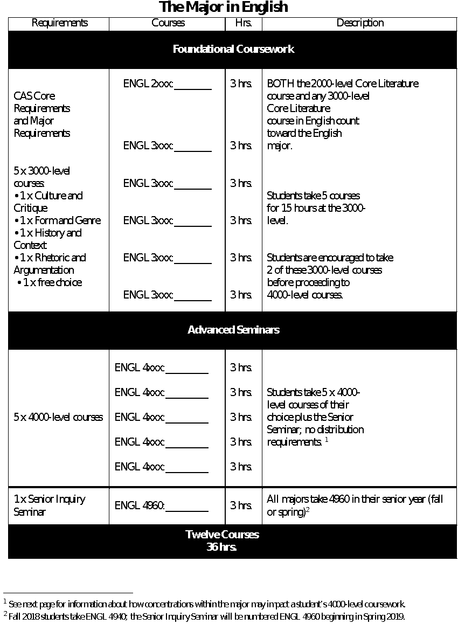

**Concentrations within the Major**

**Creative Writing (CW)**

Students completing the English major with emphasis in Creative Writing follow the Major curriculum. The difference is that students prioritize Creative Writing courses when completing **Foundational Coursework** distribution requirements at the 3000-level and **Advanced Seminars** at the 4000 level. A total of **TWELVE hours** within Creative Writing courses is required to complete the concentration.

* CW students may count up to **SIX hours** at the 3000-level towards their CW concentration: two Creative Writing courses (ENGL 3000 through 3100) offered within the Form and Genre (FG) category.
* CW students may take **SIX OR NINE hours** of additional CW courses at the 4000-level (for example, ENGL 4050: Craft of Poetry).
* Finally, in addition to taking ENGL 4960: Senior Inquiry Seminar, CW students submit a portfolio of representative work for assessment prior to graduation.

**Rhetoric, Writing and Technology (RWT)**

Students completing the English major with a concentration in Rhetoric, Writing and Technology (RWT) follow the English major curriculum. The difference is that students prioritize RWT courses when completing distribution requirements at the 3000-level and advanced seminars at the 4000-level. A total of **TWELVE hours** of RWT courses are required to complete the concentration.

**Required Course**

All students who major in English with a concentration in RWT should take the introductory course:

* ENGL 3850 Foundations in Rhetoric and Writing

**Electives**

Students in the RWT Concentration must take at least **THREE** more courses from the following:

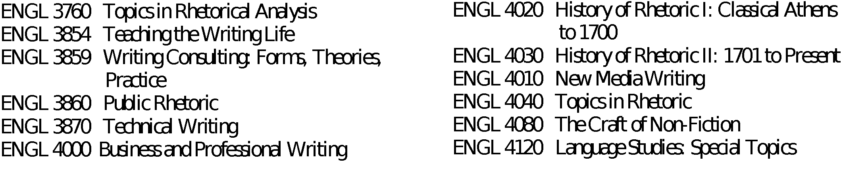

**English Honors Concentration: Research Intensive English (RIE)**

Students admitted to the departmental honors concentration (Research Intensive English) follow the English major curriculum. The difference is that English honors students prioritize RIE seminars (limited to admitted RIE students) when completing their Advanced Seminar requirements at the 4000 level.

* RIE students complete **AT LEAST TWO** RIE seminars to complete this honors concentration.
* In addition to taking ENGL 4960: Senior Seminar, RIE students complete **ENGL 4990: Senior Honors Project** under the supervision of a faculty mentor prior to graduation to complete the concentration. Students may substitute a third RIE seminar for ENGL 4990 to complete the concentration.

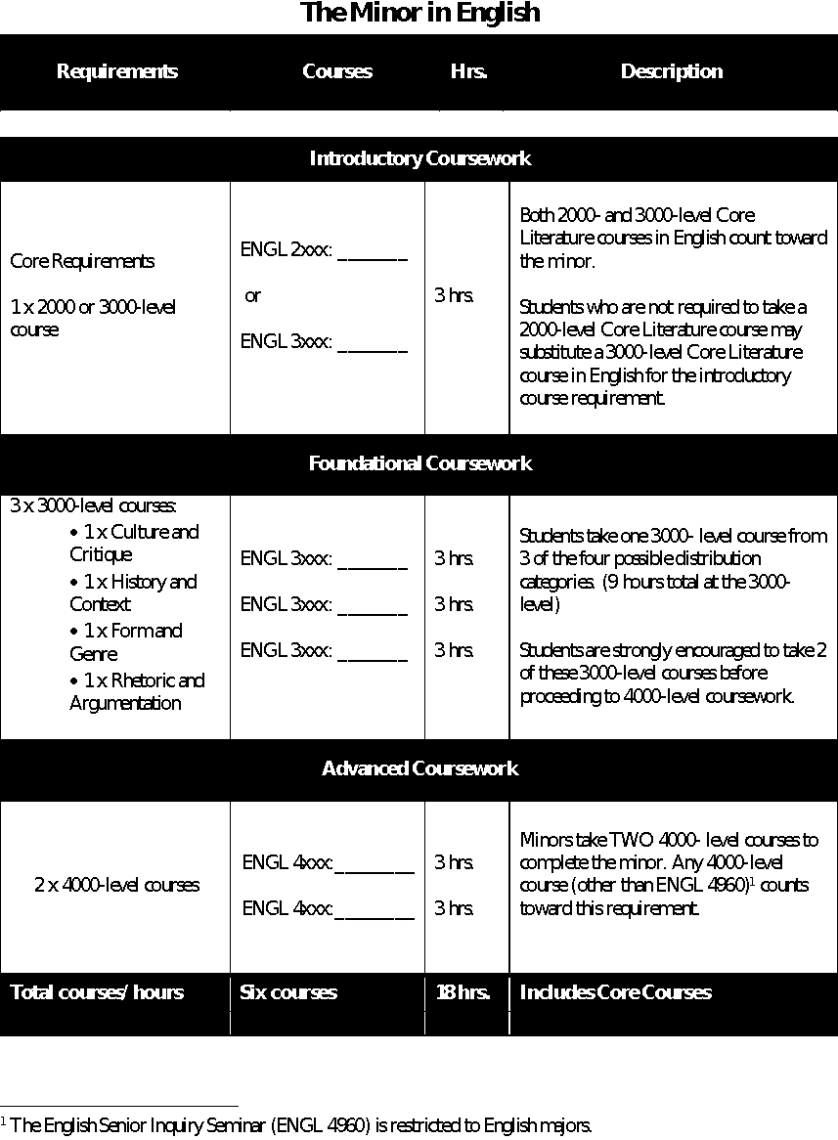

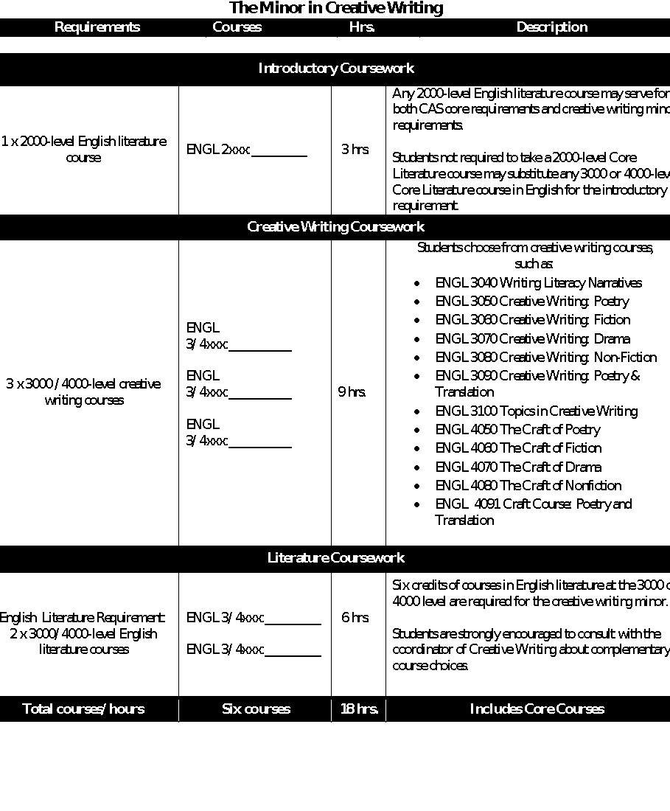

**The Internship Program**

**@SLU English**

**What can you do with an English major?**

This is the question facing many students majoring in the Humanities, especially in English.

And yet the basic skills English majors develop over the course of their study—the ability to read deeply, write coherently, think flexibly—are the bedrock of a great variety of jobs in our information age.

The Internship Program of the SLU English Department seeks to showcase and develop the strong core skills of our majors by enabling students to pursue an internship that both helps them gain meaningful work experience and procures them course credit.

**Frequently Asked Questions**

**Who is eligible to do an internship for course credit in English?**

The SLU English Department’s internship program supports upper-level English majors who wish to supplement their academic course of study with an educational work experience.

**What kind of work will I do?**

The English Department seeks to place its students in internship environments where interns go beyond performing clerical work and can make meaningful connections between their course of study and the practical, social, and intellectual demands of a workplace.

**Where would I work?**

Here are some organizations regularly seeking interns:

• River Styx Literary Journal

• The Contemporary Art Museum

• KDHX

• Regional Arts Commission

• Ralston-Purina

**What does doing an internship for course credit require?**

To ensure students have meaningful work experience, the English Department internship requires a significant academic component, one through which students augment their on-site work through a process of critical reflection and analysis.

Here are the basic elements of a SLU English internship:

• Registration for ENGL 4910

• On-site work (10 hours/week for 15 weeks)

• Academic component

• Evaluation

Internships are typically voluntary but can be taken for 3 hours of course credit within the major if the internship opportunity meets the English Department’s guidelines and requirements.

**How do I get started?**

Visit the English Department’s website: http://slu-english-internships.weebly.com. Here you can also determine whether you are eligible to register for an internship and read about the stages of the internship process. For additional questions, please contact the English Department’s Internship Coordinator, Professor Juliana Chow, at Juliana.chow@slu.edu.

A screenshot of a cell phone

Description generated with very high confidence

Dr. Hal Bush, Undergraduate Coordinator in English: hal.bush@slu.edu

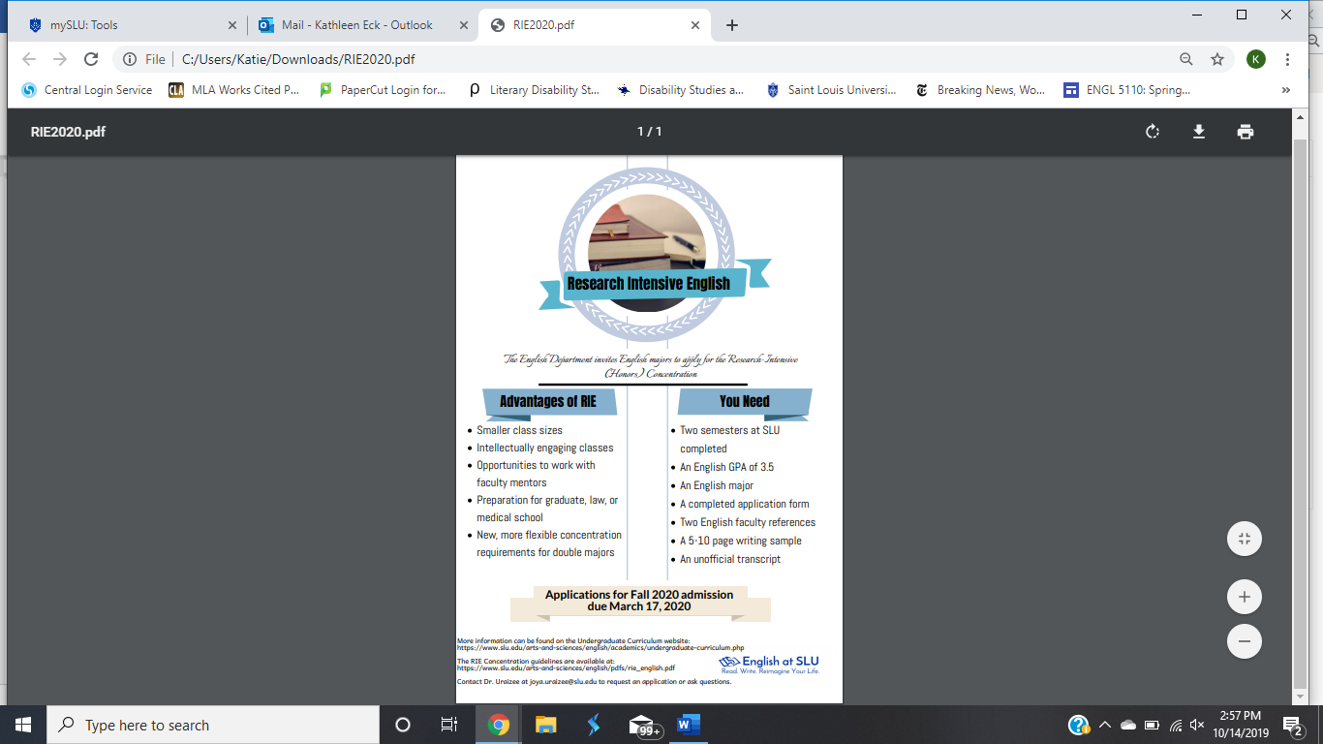

A screenshot of a cell phone

Description generated with very high confidence

Contact Dr. Hal Bush at hal.bush@slu.edu for more information on how to join.