*** ***

***Saint Louis University Gateway Geriatric Education Center***

***Geriatric Assessment Clinic***

Saint Louis University’s Health Resource Center and the Geriatric Education Center (GEC) are offering a FREE Comprehensive Geriatric Assessment clinic for people 65 years of age or older, on the first Friday of every month at the Health Resource Center located at 1408 N. Kingshighway Blvd #213, St. Louis, MO 63113.

A comprehensive assessment is more extensive than a screening appointment. The appointment is approximately two hours in length and includes assessments by medical, physical therapy, occupational therapy, nutrition, speech therapy, and social work professionals.

To schedule an appointment please contact the SLU Geriatrics Division Office at 314-977-8462.

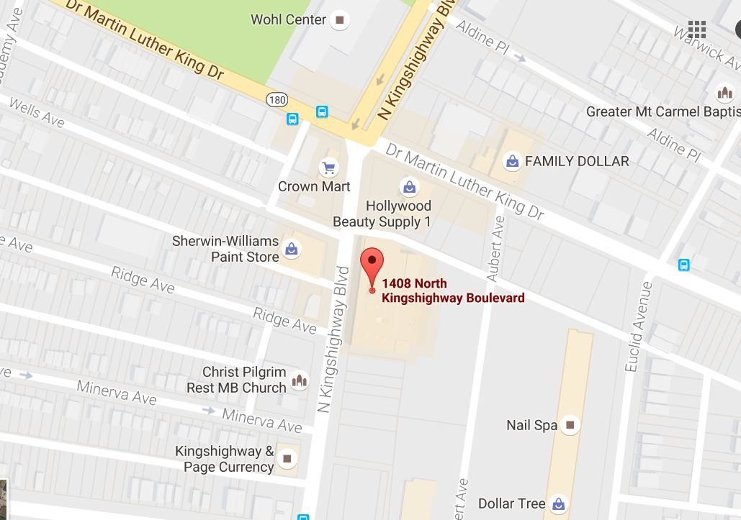

This project is supported by the Health Resources and Services Administration (HRSA) of the U.S. Department of Health and Human Services (HHS) under grant number U1QHP28716 Geriatrics Workforce Enhancement Program for $750,000. This information or content and conclusions are those of the author and should not be construed as the official position or policy of, nor should any endorsements be inferred by HRSA, HHS, or the U.S. Government.